Current Object

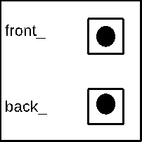

rhs





23



15



10



8

